Title/abstract title
AN UNEXPECTED INTRACARDIAC VISITOR: ACUPUNCTURE NEEDLE MIGRATION INTO THE RIGHT VENTRICLE
Background/introduction
Cardiac injury secondary to migration of an acupuncture needle is exceptionally rare and may present as life-threatening surgical emergency. Delayed transdiaphragmatic migration into the heart can result in hemopericardium, cardiac tamponade, valvular injury and great vessel involvement. Early diagnosis using multimodality imaging and prompt surgical intervention are essential for successful management and crucial to prevent catastrophic outcomes.
Methods/case description
A 50-year-old mam presented with recurrent chest pain, dyspnoea and hemopericardium following acupuncture therapy He had retained intracardiac and intrahepatic acupuncture needle following alternative therapy for coronary artery disease. This foreign body was detected incidentally during pericardiocentesis. CT thorax and intraoperative transoesophageal echocardiography demonstrated a metallic foreign body traversing the liver, diaphragm, Pericardium and right ventricle. Emergency median sternotomy was performed. The needle was carefully divided and removed in two fragments after securing the right ventricular puncture with pledgeted prolene sutures.

Results
At surgery, the needle was found penetrating the diaphragm and right ventricular free wall. A pledgeted prolene suture was placed around the puncture site, following which the needle was divided between the heart and diaphragm and removed in two fragments from the intracardiac and intrahepatic portions. Post-removal transoesophageal echocardiography confirmed complete retrieval without residual intracardiac foreign body or structural injury. The postoperative course was uneventful, and the patient was discharged in stable condition.
Conclusion/Take home message
Migrating acupuncture needles should be considered in patients presenting with unexplained hemopericardium after acupuncture therapy. Multimodality imaging is invaluable for operative planning, and prompt surgical intervention allows safe retrieval and excellent clinical outcomes even in complex penetrating cardiac injuries

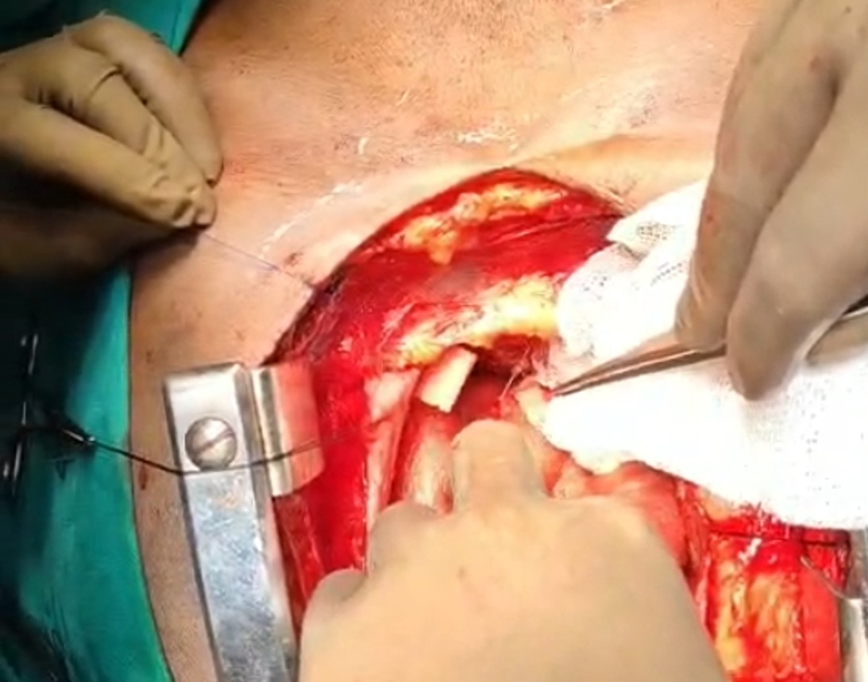
FIGURE:- arrow showing intra op pic of needle entering the RV inferior surface
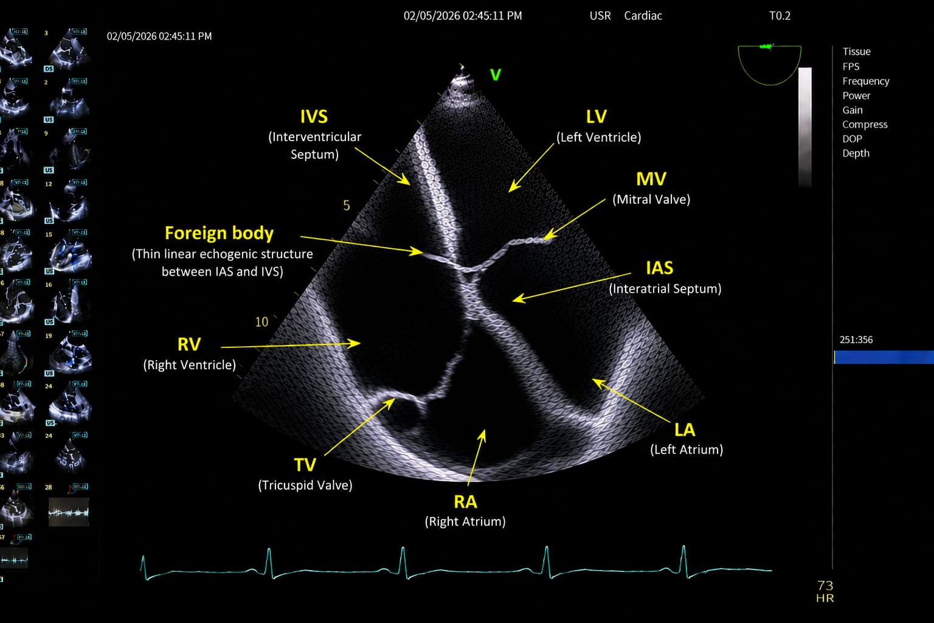
FIGURE: -echo image showing foreign body

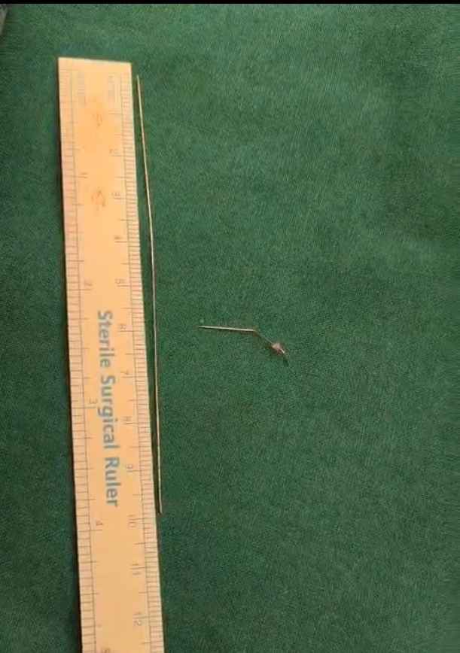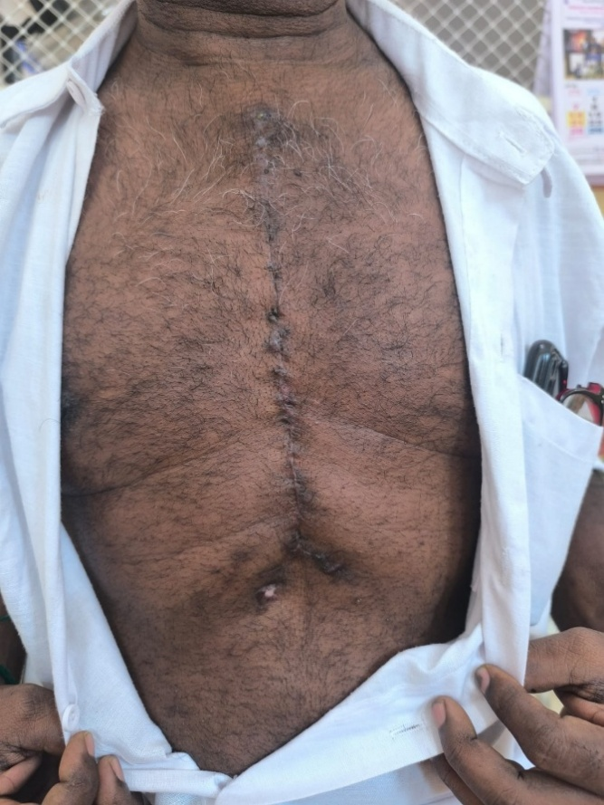

Figure: approx. 10+3.5 cm (2 segments) long acupuncture needle retrieved / post op follow up after 1 month

